**NASA-Provided ELV Launch Services Ground Rules/Policy**

This document provides additional information for NASA-provided ELV launch services.

Any Expendable Launch Vehicles (ELV) provided by NASA will be procured and managed by the NASA/Launch Services Program (LSP) using government contracts.

Under the provisions of the NASA Launch Service II (NLS II) contract, the launch service includes the launch vehicle (LV) and associated standard services, non-standard services (mission unique options), all engineering and analysis, and minimum performance standards. LSP also provides technical management of the launch service, technical insight into the LV production/test, coordinates and approves mission-specific integration activities, provides mission unique LV hardware/software development, provides payload-processing accommodations, and manages the launch campaign/countdown.

At the appropriate time following mission selection, LSP using its standing contracts will competitively select a launch service provider and award a Launch Service Task Order (LSTO) for the mission based on customer requirements. The LSTO is awarded to the Contractor that provides the best value in launch services to meet the Government's requirements based on technical capability/risk, reasonableness of proposed price, and past performance. Accordingly, assumption of a specific launch vehicle configuration as part of the AO proposal will not guarantee that the proposed LV configuration will be selected unless there is firm technical rationale for sole source. Any such rationale should be clearly identified and explained in the proposal.

All NASA-procured launch services are to be consistent with NASA Policy Directive (NPD) 8610.7, NASA Launch Services Risk Mitigation Policy. Expendable launch services acquired by NASA will be managed in accordance with NPD 8610.23, Technical Oversight of Expendable Launch Vehicle (ELV) Launch Services and NPD 8610.24, Launch Services Program (LSP) Pre-Launch Readiness Reviews. These NPD’s can be accessed through the URLs:

<http://nodis3.gsfc.nasa.gov/displayDir.cfm?t=NPD&c=8610&s=7D>

<http://nodis3.gsfc.nasa.gov/displayDir.cfm?t=NPD&c=8610&s=23C>

<http://nodis3.gsfc.nasa.gov/displayDir.cfm?t=NPD&c=8610&s=24C>

Or, they are located in the AO library.

Dual manifested or secondary payloads will not be considered under this AO.

**Contributed Domestic or Foreign Launch Vehicles**

Foreign launch vehicles will not be considered under this AO.

### Launch Vehicle Information/Configuration/Performance

The Offerors should select the minimum launch service performance class that meets their requirements including adequate performance margins. Attachment 1 describes these performance ranges in terms of mass to orbit (kilograms) for a range of C3 values. The performance data in Attachment 1 is based upon the NASA Launch Services II (NLS II) contracted performance data and is to be used for planning purposes only.  For variations from what is found in Attachment 1, refer to the contact listed in this document for an assessment. The Offerors should specifically state in the proposal the launch service performance range to meet their requirements for this mission. For a NASA-provided ELV launch service, the proposal must be designed to the enveloping launch vehicle characteristics and capabilities provided in Attachment 1.

The LSP has developed a performance website for vehicles currently on contract to NASA. This website contains information relevant to NASA-procured launch services. This planning tool can be found at the following web address: <https://elvperf.ksc.nasa.gov/Pages/Default.aspx>

Access to this site is available to anyone with an internet connection and is generally available at any time. For questions, utilize the point(s) of contact listed in this document.

**Launch Service Costs**

Attachment 1 describes performance ranges for eight categories of launch vehicles in the intermediate performance class. The “baseline” service is based upon the “Low” performance curve with a 4-m fairing with a launch readiness date of NLT Dec 31, 2024. Attachment 1 also shows the composite launch vehicle environments and two difference performance-specific payload 4-m fairing static envelopes that would ensure compatibility across the range of potential launch vehicles currently available under the baseline launch service for which demonstrated compatibility is expected.

The launch vehicle standard services will be provided as Government-Furbished Equipment (GFE). These costs will not be included in the PI cost cap. The cost of mission specific and special launch services is the responsibility of the PI and must be included within the cost cap. For purposes of this AO, a charge will be reflected against the PI-Managed Mission Cost for investigations that require the use of more capable launch vehicles, beyond the description below, or for services beyond the standard launch services described below.

The Solar Terrestrial Probes #5 Interstellar Mapping and Acceleration Probe (IMAP) mission will hold the launch service costs. Services provided in the launch service costs to be covered by the IMAP mission are:

* the launch vehicle, engineering, analysis, and minimum performance standards and services provided by the NLS contract in place at the time of LV selection;
* mission integration;
* launch site payload processing;
* range safety support;
* down range telemetry support (launch vehicle data only);
* nominal allocation for non-standard/mission unique launch vehicle modifications/services – items typically necessary to customize the basic vehicle hardware to meet spacecraft driven requirements.

See Attachment 2 for a list of all services included in the STP-5 (IMAP) AO.

The STP-5 (IMAP) LV budget set aside for this AO does not include funding for PI caused launch delays.

**Evaluation Criteria**

Attachment 3 shows a preliminary Evaluation checklist to be used as a guide for the evaluators during the proposal evaluation phase. This checklist should provide an indication of the types of information that are expected to be contained in the proposals. If the proposal does not provide sufficient information to be evaluated for each section, the launch vehicle section of the proposal may not be evaluated for full content and may be listed as a finding.

## NASA Launch Services Program Point of Contact for Additional Information

Additional information including performance quotes, mission integration inquiries, and costs for non-standard services may be obtained from the point of contact below. Otherwise questions must be directed as indicated in the Technical and Scientific Inquiries section of the AO.

**Jim Hall**

**Mission Manager**

**NASA Launch Services Program**

**Mail Code: VA-C**

**Kennedy Space Center, FL 32899**

**Phone: 321-867-6218**

**Email: james.l.hall@nasa.gov**

**ELV Launch Services Characteristics/Capabilities**

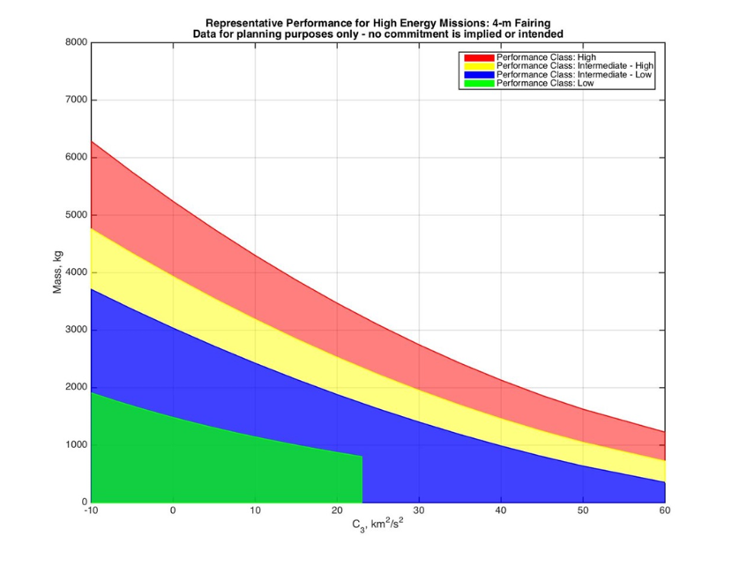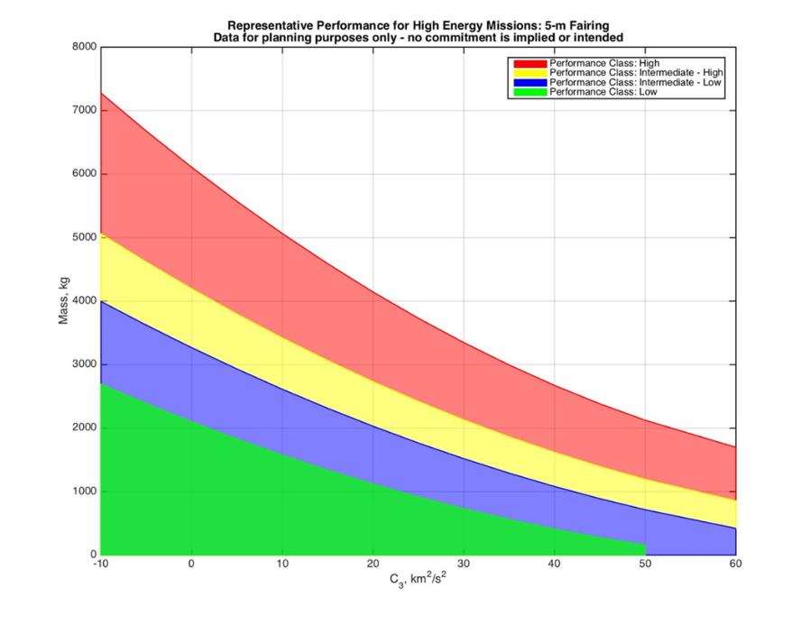

Performance Ground Rules:

* This LV performance available on NLS-II generally does not include impacts associated with orbital debris compliance; this must be evaluated on a mission-specific basis. Depending on the LV configuration, this could result in a significant performance impact to ensure full compliance with orbital debris policy.
* Guidance reserves have been allocated to account for 3-sigma flight performance.
* Performance is for baseline LV configuration; non-standard, mission-unique hardware will require additional assessment.
* 1194-mm marmon-type clampband separation system and adapter.

.

**Payload Fairing Envelope:**

Figure 1 and Figure 2 below shows the performance-specific static payload fairing envelopes. Figure 1 is the static envelope associated with the Low performance class and Figure 2 is the static envelope associated with the Intermediate-Low, Intermediate-High and High performance classes.  Proposers must use the payload envelope associated with the accompanying performance class to ensure compatibility with all current potential launch vehicle configurations.

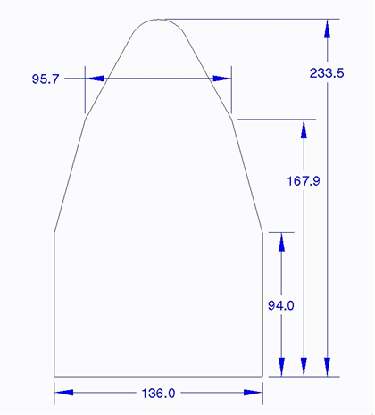

**Figure 1: 4m Static Payload Fairing Envelope (Low Performance Class)**

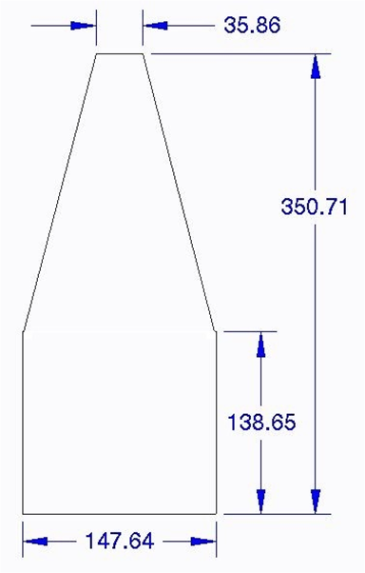

**Figure 2: 4m Static Payload Fairing Envelope (Intermediate-Low, Intermediate-High   
and High Performance Class)**

**Launch Vehicle Environments**

The maximum positive axial CG Load Factor (compression) is a function of the spacecraft mass. For estimates, please contact to the POC listed in this information summary and provide the lower estimate for the spacecraft mass (more conservative) in order to supply the applicable CG Load Factors.

**NASA-LSP Standard and Nominal Mission Unique Launch Services**

This list provides an overview of the standard services that the spacecraft customer receives with NASA-LSP as their launch service provider.

**Integrated Services:**

Range support and services

Payload processing facility and support

Contractor engineering support

Base support contractors

Logistics

Hazardous support

**Nominal Launch Vehicle Services:**

Launch vehicle that meets customer’s performance needs for a NLT Dec 31 2024 launch

Payload fairing with approximately 2 access doors with thermal and/or acoustic blankets

Standard LV-provided payload separation system

Standard payload adapter

Standard test payload adapter availability

Spacecraft spin/de-spin capability for separation (if required)

Single-Spacecraft

Collision/contamination avoidance maneuver (CCAM) capability if needed

Electrical interface connectors (approximately 3 sets)

Mission unique reviews (approximately 3)

Readiness reviews (approximately 4)

Risk management

Launch vehicle insight and approval

Mission integration management & engineering support

Launch campaign management

Down range telemetry assets for LV data

**The following typical Mission Unique Services are included in the baseline vehicle cost:**

T-0 GN2 or pure air purge

ISO 14644-1 Class 7 integration environment

Interleaved Spacecraft Telemetry

**Evaluation Form**

**Launch Services Program**

Proposal Name: ___________________________________________________________________

Proposal #: _______________________________________________________________________

Evaluator POC: ___________________________________________________________________

Phone: __________________________________________________________________________

Email: ___________________________________________________________________________

**Launch Service Technical Evaluation:**

**Overall Assessment**: - Given the ground rules in the AO, is the proposed launch vehicle (LV) concept feasible for this application? (Yes or  No)

Comments:___________________________________________________________________________________________________________________________________________________________________________________

**LV Performance:** Area of concern (Yes or  No)

Proposed LV configuration: ___________________

Proposed Launch Date: ______________________

Launch Period (MM/DD/YYYY to MM/DD/YYYY): ______/____/_____ to _______/____/_____

Launch Window (On any given day of the launch period Minutes:Seconds): _______ : ______

Orbit requirements: Apogee: __________ km Perigee: ___________ km Inclination:__________deg.

High Energy requirements: C3: ______ km2/sec2 DLA: ______deg RLA: ______deg

Proposed LV Performance: _________

Mass (including reserves) Dry Mass: ___________ kg Wet Mass: ____________ kg

Dry Mass Margin: _____________ kg ____________ %

Wet Mass Margin _____________ kg ____________ %

Formulas:

Mass Margin kg = LV Performance – S/C Mass (including reserves)

Mass Margin % = [(Mass Margin kg)/ S/C Mass (including reserves) kg] X 100

LV Performance Comments/issues/concerns: ____________________________________________________________________________________________________________________________________________________________________________________________

**Launch Service Cost Assessment:** Area of concern (Yes or  No)

Is there additional funding for any mission unique modifications/services? (Yes or  No)

**LV Integration:** Area of concern (Yes or  No)

Does the proposer have experience in LV integration? (Yes or  No)

**LV to Spacecraft Interface**: Area of concern (Yes or  No)

Proposed Payload Fairing (PLF) ________________

Spacecraft (S/C) Dimensions: Radial:________ m Height ________ m

Any intrusions outside of the PLF usable *static* volume? (Yes or  No)

Mechanical Interface:

Standard Adapter: _____________ Custom Adaptor: __________________

Electrical Interface:

Standard _____ Pin(s) Connector(s): (Yes or  No)

Mission Unique requirements:

Instrument T-0 GN2 Purge: (Yes or  No)

T-0 S/C Battery Cooling: (Yes or  No)

Planetary Protection Requirements: (Yes or  No)

Contamination Control Requirements: PLF: (Yes or  No) LV adapter: (Yes or  No)

Cleanliness Level: ___________ other: ____________________

Unique Facility Requirements: (Yes or )

Pad: ___________________________________________

S/C Processing Facility: __________________________

S/C Environmental Test Plans

Environmental Test Plan/Flow described: (Yes or  No)

Test Levels provided: (Yes or  No)

Test Schedule provided: (Yes or  No)

Comments/issues/concerns: _______________________________________________________________

**Spacecraft Schedule**: Area of concern (Yes or  No)

Adequate timing of: Launch Service Integration Start Time: Yes or  No)

S/C Environmental Test Program: (Yes or  No)

Delivery of Verified S/C Loads Model: (Yes or  No)

S/C ship date: (Yes or  No)

S/C to LV integrated Operations: (Yes or  No)

**Missions with Radiological material** Area of concern (Yes or  No)

List the Radiological Sources: __________________________________________________

Are unique facilities required to store/process the Radiological Sources? (Yes or  No)

Any LV modifications required for additional safety or Launch approval? (Yes or  No)

END OF DOCUMENT